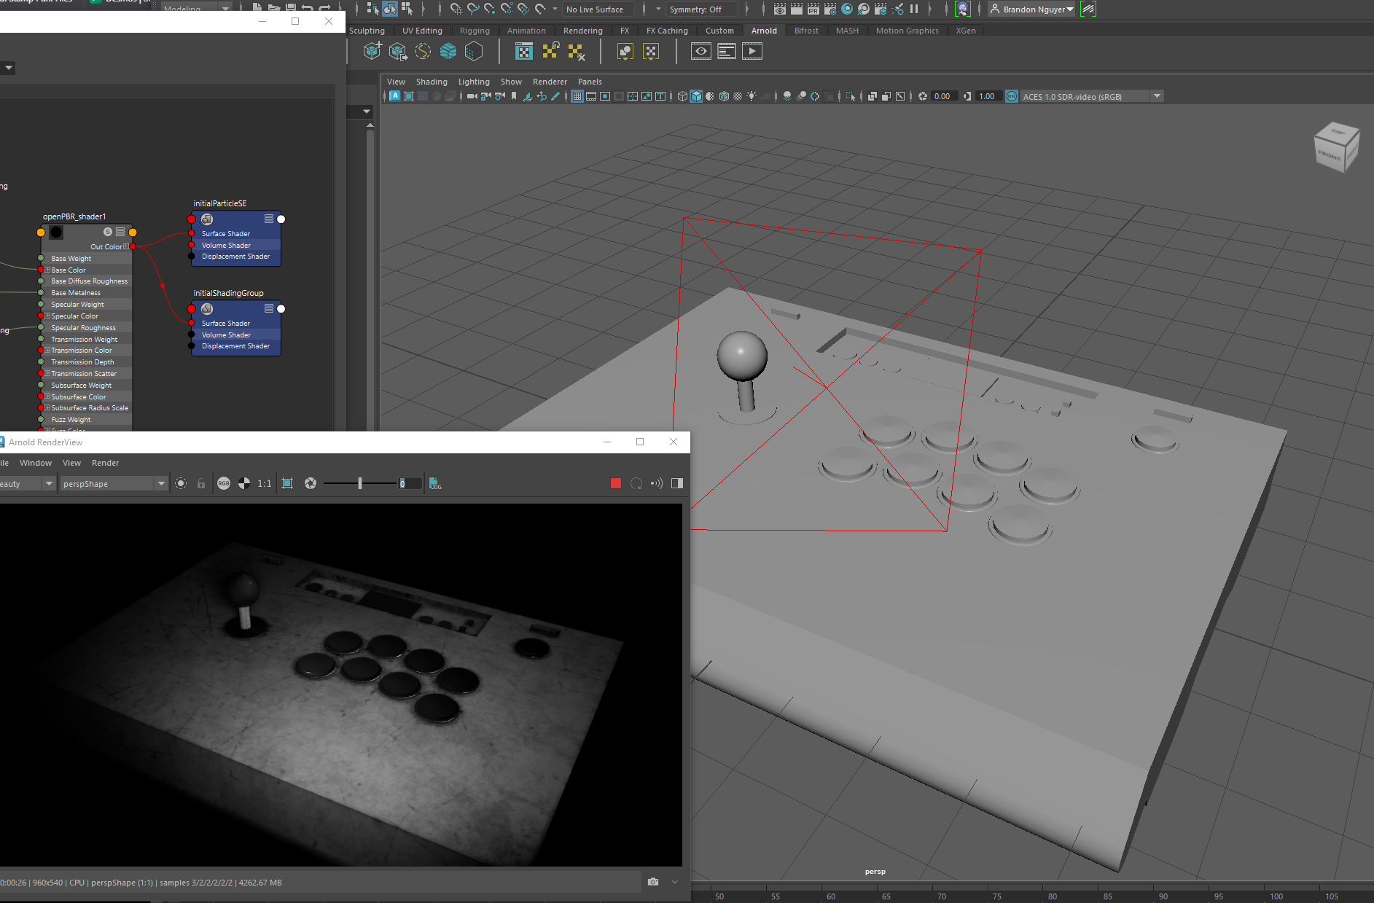
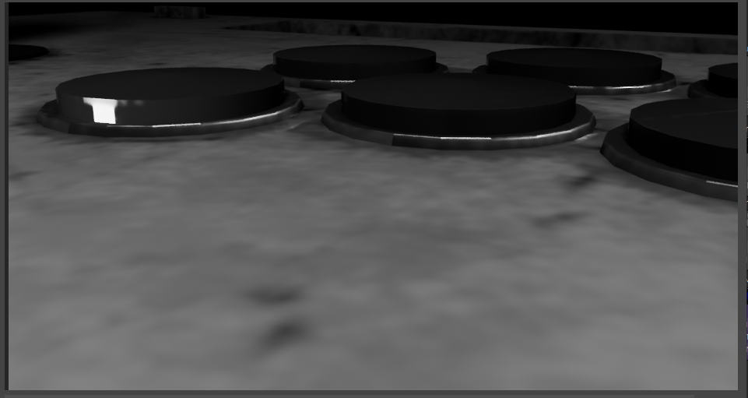
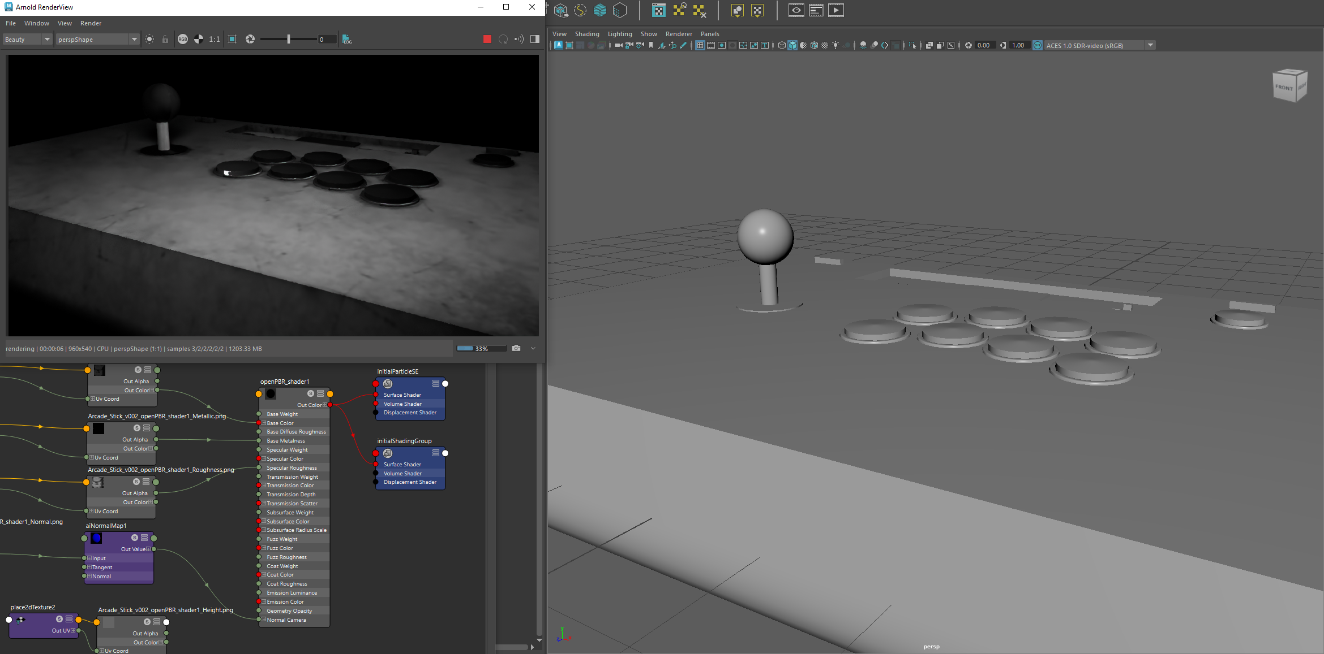
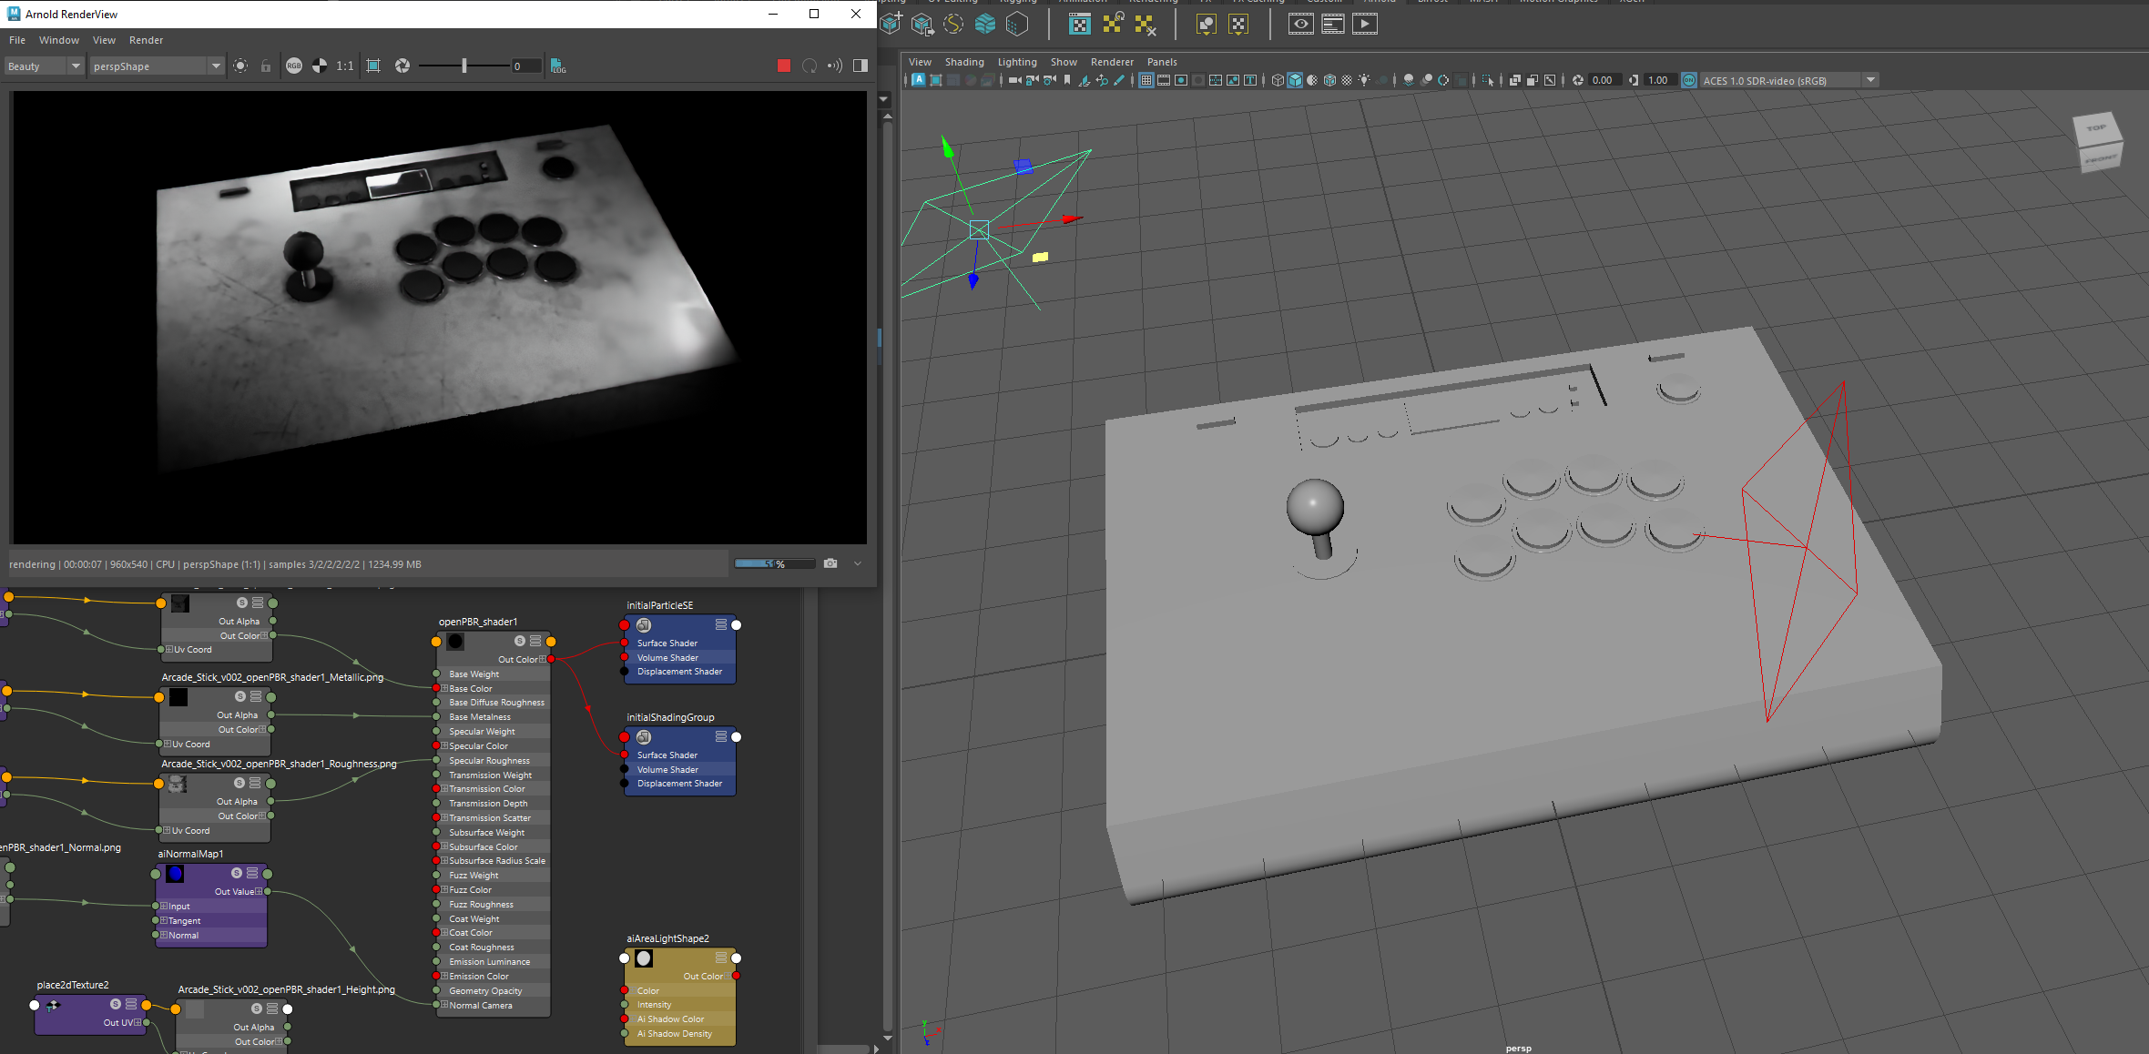
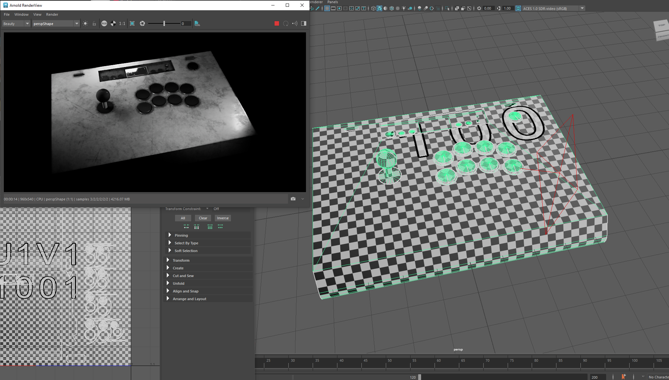
There are many things in life that are inevitable. Node views seem to be one of them. It does make sense in the context of what’s going on, organizing the necessary information and controls needed for this type of texturing within Maya. However, it does seem a little unintuitive. Alphas aren’t exactly self-explanatory, for one. I’m curious if there are methods similar to Toon Boom when it comes to organizing the nodes, such as something that would organize the nodes into groups. Messing around with the lighting and render view was nothing new, howev
er. I have been using this program since high school.

https://github.com/KiribosBriskit/DAGV-Projects

